Directions for getting access to your NALC 84 Labor Tracks system.

Branch 84 has been using a web based tool for processing grievances and tracking management. This tool now provides the ability for rank and file members to receive updates regarding the grievances that they are associated with. This information can be accessed in two ways. A union member can log into the system at www.labortracks.com to review their information and via automatic email notifications that inform them when a change has been made to their grievance. In addition to accessing grievance data, members will be able to type witness statements into the system so that these important pieces of information can be collected more efficiently.

To gain access to this tool a user must have a valid email account and follow these steps:
- Have a valid email address (for example GoStillers123@gmail.com)
- Contact NALC Branch 84 and provide them the email address
- NALC 84 administration will email you a username
- You will open a web browser and go to http://www.labortracks.com
- Click on “Forgot your password?”
- Enter the following information in the spaces provided:
  - The username your local emailed to
  - reCAPTCHA words in the spaces provided.
A
A
A
- Click the “Retrieve Password” button. An email with your password will be sent to the email account you provided your branch administration.
- You can now return to http://www.labortracks.com, enter your username and password in the spaces provided, and click the “Sign In button to begin accessing your information.
- Once you are logged in you can access your grievances and witness statements by clicking on the Grievances menu.
A
- Your Grievances or witness statements will be listed as follows. You can access grievance details by clicking on the details link in the right hand column. 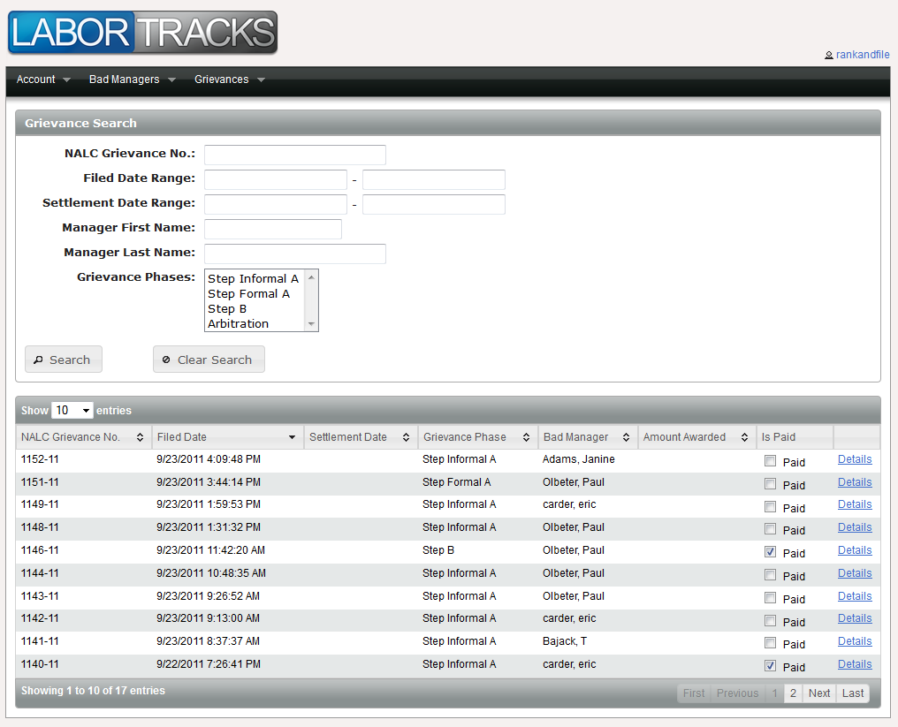
- Please remember if your grievance has been resolved and a settlement has been awarded to you to mark the “Paid” checkbox if you have received the money/hours awarded to you. Doing so will communicate this information back to your elected officials so that they may work to get others compensated as well.

